

FINAL PROJECT

FUNDAMENTALS OF MANAGEMENT

**GROUP MEMBERS:** ABDUL HAQ, BADAR FAISAL, AZGHAN, ZUBAIR ALI.

**ROLL NUMBERS:** 22I-2585,22I-2507, 22I-2667, 22I-2591.

**DEGREE PROGRAM:** BS SOFTWARE ENGINEERING (BATCH 2022).

**SECTION:** B.

**SUBMITTED TO:** NADEEM AWAN

**FAST-NUCES Islamabad Campus**

**SUBMISSION DATE: 6 June 2024.**

Contents

Introduction: 5

Introduction to the Era 5

1.1 Socio-Political Landscape: 5

Relevant Hadith (Tirmidhi): 5

1.2 Pivotal Pre-Birth Events: 6

Relevant Hadith (Sahih Muslim): 6

Early Life and Family Background 6

2.1 Family Background and Upbringing: 6

Relevance to Management: 6

2.2 Lessons from Upbringing Relevant to Management: 6

Relevant Hadith (Sahih Muslim): 7

Pre-Prophethood Career and Responsibilities 7

3.1 Roles and Responsibilities in the Community: 7

Relevance to Management: 7

3.2 Demonstrations of Leadership and Organizational Skills: 8

Relevant Hadith (Sahih Bukhari): 8

Events Related to Management: 8

Management Principles in Mecca 9

4.1 Management of Personal and Community Affairs: 9

Relevance to Management: 9

4.2 Governance, Decision-Making, and Conflict Resolution: 10

Relevant Hadith (Sahih Muslim): 10

Management Principles in Madina: 11

5.1 Establishment of the Islamic State: 11

5.2 Social Welfare and Community Development: 11

Relevant Hadith: 12

Events Related to Leadership: 12

Legacy of Prophet Muhammad: 13

6.1 Moral and Ethical Leadership: 13

Relevance to Leadership: 14

6.2 Interfaith Relations and Religious Tolerance: 14

Relevant Hadith: 14

Legacy of Compassion and Mercy: 14

Events Related to Legacy: 14

Prophet’s Year of Grief: 15

7.1 The Boycott Imposed on the Prophet and His Followers: 15

7.2 Impact on the Muslim Community: 15

7.3 The Year of Grief: 16

7.4 Lessons in Resilience and Perseverance: 16

7.5 Relevance to Leadership: 16

Migration To Madinah: 16

8.1 Journey to Taif: 16

8.2 Lessons in Resilience and Patience: 16

8.3 Migration to Madinah (Hijrah): 17

8.4 Relevance to Leadership and Strategic Planning: 17

*8.5 Leadership Lessons from Migration to Madinah:* 17

Treaty of Hudaybiyyah 18

9.1 Battle of Badr: 18

*9.2 Leadership Roles:* 20

Leadership and Decision-making: 20

*Execution and Adaptation:* 21

After Hudaibiyah till blessed Aparent Demise: 21

Strategic Planning : 22

Crisis Management and Flexibility: 22

Inclusive Leadership: 23

Communication and Diplomacy: 23

Adaptability and Contextual Decision-Making: 23

Blessed Attributes and Appearance of the Holy Prophet (PBUH) 23

Personal Presence and Charisma: 23

Clarity and Eloquence in Communication: 24

Integrity and Ethical Conduct: 25

Conclusion: 25

# 

# **Topic:**

# **Seerat e Nabi (SAW)**

# **Introduction:**

Embarking on a journey through the fundamental principles of management, we delve into a pivotal era marked by the dawn of the Holy Prophet Muhammad's life. Amidst the intricate tribal dynamics and societal upheavals of the Arabian Peninsula, his emergence as a beacon of divine guidance shaped not only the course of history but also offers timeless lessons for contemporary management. From his early upbringing to pre-prophethood endeavors, and pivotal events like the Treaty of Hudaybiyyah, his life exemplifies principles of resilience, empathy, strategic planning, and inclusive leadership. Join us as we unravel the management insights woven within the tapestry of the Prophet's life, guiding us towards ethical leadership and organizational stewardship in today's complex world.

# **Introduction to the Era**

## **1.1 Socio-Political Landscape:**

*During the birth of the Holy Prophet Muhammad, the Arabian Peninsula was embroiled in intricate tribal dynamics, where tribal allegiance often overshadowed principles of justice and equality. The prevailing polytheistic beliefs centered around the Kaaba in Mecca fostered a culture of idol worship and pagan rituals, further entrenching societal divisions. Social injustices, particularly towards the marginalized and downtrodden, underscored the urgent need for ethical guidance and moral reform.*

*Key Quranic Verse* ***(Surah Al-Ankabut 29:69):***

**"وَالَّذِينَ جَاهَدُوا فِينَا لَنَهْدِيَنَّهُمْ سُبُلَنَا ۚ وَإِنَّ اللَّهَ لَمَعَ الْمُحْسِنِينَ"**

***"Allah emphasizes the significance of righteousness and guidance as fundamental pillars in rectifying a morally deteriorating society, urging individuals to uphold moral principles despite societal challenges."***

## **Relevant Hadith (Tirmidhi):**

*The Prophet Muhammad stresses the transformative power of good deeds in shaping individual character and earning divine favor amidst the prevalent moral decadence, highlighting the pivotal role of ethical conduct in navigating societal turmoil.*

## **1.2 Pivotal Pre-Birth Events:**

*The era preceding the Holy Prophet's birth witnessed significant events that laid the groundwork for his prophetic mission. The Year of the Elephant, characterized by Abraha's futile attempt to desecrate the sanctity of the Kaaba through military aggression, served as a poignant reminder of divine intervention against injustice and oppression.*

*Key Quranic Verse* ***(Surah Al-Fil 105:1-5):***

"**أَلَمْ تَرَ كَيْفَ فَعَلَ رَبُّكَ بِأَصْحَابِ الْفِيلِ"**

***"The miraculous protection of the Kaaba from Abraha's onslaught signifies Allah's omnipotence and divine intervention in safeguarding sacred symbols of faith, demonstrating His unwavering commitment to uphold justice and protect the righteous."***

## **Relevant Hadith (Sahih Muslim):**

*The Prophet Muhammad articulates his mission as a manifestation of divine mercy to all creation, emphasizing his role as a beacon of compassion and guidance amidst the tumultuous societal landscape, thereby illuminating the path towards righteousness and moral rectitude.*

# **Early Life and Family Background**

## **2.1 Family Background and Upbringing:**

*The formative years of the Holy Prophet Muhammad were shaped by his family background and early life experiences. Born into the esteemed Quraysh tribe of Mecca, Muhammad encountered the loss of his parents during childhood, fostering within him qualities of resilience, empathy, and independence. Raised under the guardianship of his grandfather and later his uncle Abu Talib, he imbibed values of integrity, honesty, and compassion.*

## **Relevance to Management:**

*The Prophet's familial upbringing holds profound implications for management, offering insights into the development of leadership qualities. Recognizing the significance of resilience, empathy, and independence can empower managers to cultivate effective leadership strategies and nurture a conducive work environment.*

## **2.2 Lessons from Upbringing Relevant to Management:**

*Resilience: The Prophet's ability to endure adversity underscores the importance of resilience in leadership. Managers who exhibit resilience can navigate challenges adeptly, inspire their teams amidst difficulties, and steadfastly pursue organizational objectives .*

*Empathy: Muhammad's upbringing without parental guidance cultivated a profound sense of empathy towards others' struggles. Managers who demonstrate empathy can forge meaningful connections with their team members, comprehend their needs, and foster a workplace culture founded on compassion and understanding .*

*Independence: Nurtured in a society where tribal affiliations held sway, the Prophet's upbringing instilled a sense of independence and self-reliance. Effective managers empower their employees to make autonomous decisions, take ownership of their tasks, and contribute innovatively to organizational progress, thereby fostering a culture of accountability and creativity .*

*Relevant Quranic Verse* ***(Surah Al-Insan 76:9):***

"**وَيُؤْثِرُونَ عَلَىٰ أَنفُسِهِمْ وَلَوْ كَانَ بِهِمْ خَصَاصَةٌ"**

*"Allah extols those who prioritize the welfare of others over themselves, reflecting the Prophet's empathetic disposition and underscoring the importance of altruism in leadership roles."*

## **Relevant Hadith (Sahih Muslim):**

*The Prophet Muhammad, in a Hadith preserved in Sahih Muslim, emphasizes the paramountcy of empathy and compassion in leadership, asserting that those who show mercy will receive mercy from the Most Merciful, thus elucidating the reciprocal nature of kindness and empathy in interpersonal relationships.*

# **Pre-Prophethood Career and Responsibilities**

## **3.1 Roles and Responsibilities in the Community:**

*Before assuming prophethood, the Holy Prophet Muhammad undertook diverse roles and significant responsibilities within his community. As a revered member of the Quraysh tribe in Mecca, Muhammad was renowned for his simplicity, integrity, and reliability. Engaging actively in social welfare initiatives, he mediated disputes, aided the underprivileged, and upheld justice in the community.*

## **Relevance to Management:**

*The Prophet's pre-prophethood endeavors underscore the pivotal role of integrity, social consciousness, and community involvement in effective leadership. Managers can glean valuable lessons from Muhammad's example by prioritizing ethical conduct, serving the community, and fostering mutual trust and respect among team members.*

## **3.2 Demonstrations of Leadership and Organizational Skills:**

*Throughout his pre-prophethood tenure, the Prophet Muhammad exhibited exemplary leadership and organizational acumen across various contexts. Renowned for his adeptness in conflict mediation, coalition building, and institution of systems for social welfare and justice, he exemplified strategic foresight, resource coordination, and efficient task delegation.*

*Relevant Quranic Verse* ***(Surah Al-Anbiya 21:107):***

**"وَمَا أَرْسَلْنَاكَ إِلَّا رَحْمَةً لِّلْعَالَمِينَ"**

***"Allah extols the Prophet Muhammad as a mercy to all realms, underscoring his compassionate leadership style and profound concern for the welfare of humanity."***

## **Relevant Hadith (Sahih Bukhari):**

*In a Hadith preserved in Sahih Bukhari, the Prophet emphasizes the pivotal role of honesty and integrity in leadership, affirming that truthfulness paves the path to righteousness and, ultimately, Paradise.*

## **Events Related to Management:**

* **Conflict Resolution:** *Central to the Prophet's pre-prophethood endeavors was his role as a mediator and arbitrator in resolving disputes within the community. His adeptness in listening to divergent viewpoints, understanding underlying grievances, and crafting mutually agreeable solutions epitomizes effective conflict resolution strategies for managers.*
* **Community Welfare*:*** *Muhammad's active involvement in social welfare initiatives, including support for the marginalized and advocacy for justice, underscores the significance of corporate social responsibility and community engagement in managerial practices. Managers can draw inspiration from his dedication to societal service and promotion of equity both within and beyond organizational confines.*
* **Organizational Skills:** *The reconstruction of the Kaaba under the Prophet's leadership serves as a testament to his strategic planning, resource allocation, and delegation competencies. Managers can derive insights from this historical event to refine their organizational abilities, streamline processes, and optimize resource utilization for the attainment of organizational objectives.*

#### **Further Considerations for Reflection:**

* **Communication Skills:** *The Prophet Muhammad's exceptional communication skills played a crucial role in conveying messages effectively, resolving conflicts, and inspiring his followers. Managers can learn from his ability to communicate clearly, empathetically, and persuasively to engage and motivate their teams.*
* **Decision-Making:** *Throughout his pre-prophethood career, the Prophet faced various challenges that required sound decision-making. His ability to make wise and just decisions, considering the well-being of the community, serves as a valuable lesson for managers in making ethical and strategic decisions that benefit the organization and its stakeholders.*
* **Team Building:** *The Prophet's skill in uniting diverse groups and fostering a sense of unity and cooperation among his followers is a testament to his team-building capabilities. Managers can draw inspiration from his approach to building strong, cohesive teams based on mutual respect, trust, and shared goals.*
* **Adaptability and Resilience*:*** *The Prophet Muhammad's resilience in the face of adversity and his ability to adapt to changing circumstances are essential qualities for effective leadership. Managers can learn from his example of remaining steadfast in challenging situations, adapting to new environments, and leading with grace and determination.*

# **Management Principles in Mecca**

### 4.1 Management of Personal and Community Affairs:

*In Mecca, the Prophet Muhammad exemplified exceptional management of personal and community affairs, showcasing a holistic approach to leadership that balanced individual well-being with the welfare of the community. His ability to navigate personal responsibilities, community leadership, and social advocacy with wisdom and compassion serves as a timeless model for effective management.*

### Relevance to Management:

*Muhammad's management of personal and community affairs highlights the significance of integrity, empathy, and inclusivity in managerial roles. Managers can draw inspiration from his commitment to ethical conduct, relationship-building, and stakeholder engagement to foster a culture of trust, collaboration, and sustainable success within their organizations.*

### 

### 4.2 Governance, Decision-Making, and Conflict Resolution:

*During his time in Mecca, the Prophet Muhammad demonstrated remarkable governance, decision-making, and conflict resolution skills that are invaluable for modern-day managers facing complex challenges. His leadership in times of adversity, coupled with strategic decision-making and diplomatic conflict resolution, set a high standard for effective management practices.*

*Relevant Quranic Verse* ***(Surah Al-Hujurat 49:10):***

**"إِنَّمَا الْمُؤْمِنُونَ إِخْوَةٌ فَأَصْلِحُوا بَيْنَ أَخَوَيْكُمْ وَاتَّقُوا اللَّهَ لَعَلَّكُمْ تُرْحَمُونَ"**

***"Surah Al-Hujurat (49:10) emphasizes the importance of resolving conflicts and maintaining peace among believers, reflecting the Prophet's teachings on conflict resolution and community harmony."***

### Relevant Hadith (Sahih Muslim):

*A Hadith from Sahih Muslim underscores the Prophet's emphasis on seeking reconciliation in conflicts, emphasizing the significance of peaceful resolution and unity in decision-making processes.*

#### **Events Related to Management:**

* **Governance:** *The establishment of the first Islamic community in Mecca under the Prophet's leadership exemplifies his governance skills in organizing and managing a diverse group of followers. Managers can learn from his inclusive leadership style, participatory decision-making, and commitment to justice in governance practices.*
* **Decision-Making:** *The strategic decision to migrate (Hijrah) to Medina in response to persecution in Mecca showcases the Prophet's foresight and courage in making pivotal decisions for the well-being of the community. Managers can glean insights from his risk assessment, strategic planning, and decisive action in times of crisis for organizational resilience and growth.*
* **Conflict Resolution:** *The Treaty of Hudaybiyyah stands as a testament to the Prophet Muhammad's diplomatic skills and commitment to peaceful conflict resolution. Managers can benefit from his patience, negotiation prowess, and focus on long-term relationships in resolving conflicts and fostering collaboration within teams or with external partners.*

# **Management Principles in Madina:**

## **5.1 Establishment of the Islamic State:**

*Upon migrating to Medina, the Prophet Muhammad laid the foundation for the first Islamic state, showcasing his visionary leadership in establishing a cohesive community based on principles of justice, equality, and unity. His leadership during this transformative period exemplified strategic planning, community engagement, and institution-building to create a society grounded in faith and social welfare.*

* **Relevance to Leadership:***The Prophet's leadership in establishing the Islamic state highlights the importance of visionary leadership, community empowerment, and institution-building in fostering sustainable growth and development. Leaders can draw inspiration from Muhammad's approach to governance, community engagement, and strategic planning to create inclusive and thriving organizational cultures.*

## **5.2 Social Welfare and Community Development:**

*In Medina, the Prophet Muhammad prioritized social welfare and community development initiatives to address the needs of vulnerable populations and promote social cohesion. His emphasis on charity, compassion, and solidarity laid the groundwork for a compassionate society that cared for the marginalized and empowered individuals to contribute positively to the community.*

***Relevant Quranic Verse: Surah Al-Baqarah (2:177)***  
***“Goodness does not consist in turning your face towards East or West. The truly good are those who believe in God and the Last Day, in the angels, the Scripture, and the prophets; who give away some of their wealth, however much they cherish it, to their relatives, to orphans, the needy, travelers and beggars, and to liberate those in bondage; those who keep up the prayer and pay the prescribed alms; who keep pledges whenever they make them; who are steadfast in misfortune, adversity, and times of danger. These are the ones who are true, and it is they who are aware of God.”****emphasizes the importance of charity, social welfare, and compassion towards those in need, reflecting the Prophet's teachings on social justice and community development.*

## **Relevant Hadith:**

***In a Hadith narrated in Sahih Bukhari, the Prophet Muhammad highlighted the significance of caring for widows, orphans, and the less fortunate, underscoring the importance of social welfare and community support in Islamic teachings.***

## **Events Related to Leadership:**

* **Community Empowerment:** *The establishment of the Constitution of Medina, a social contract that outlined the rights and responsibilities of diverse religious communities, exemplifies the Prophet's commitment to inclusive governance, social cohesion, and community empowerment. Leaders can learn from his inclusive leadership style, respect for diversity, and promotion of social harmony in fostering cohesive communities.*
* **Institution-Building:** *The establishment of key institutions in Medina, such as the mosque, marketplaces, and arbitration mechanisms, reflects the Prophet's focus on institution-building, infrastructure development, and governance structures to support community growth and well-being. Leaders can glean insights from his strategic approach to institution-building and capacity development for sustainable community development.*
* **Social Justice:** *The redistribution of wealth and resources in Medina to address economic disparities and ensure social justice exemplifies the Prophet's commitment to equitable distribution, poverty alleviation, and empowerment of marginalized groups. Leaders can draw lessons from his emphasis on social justice, economic empowerment, and inclusive development strategies for creating equitable and thriving societies.*

*By exploring the Prophet's leadership in Medina, including the establishment of the Islamic state, social welfare initiatives, and community development efforts, leaders can gain valuable insights into visionary leadership practices, community empowerment strategies, and social justice principles that foster inclusive and prosperous societies.*

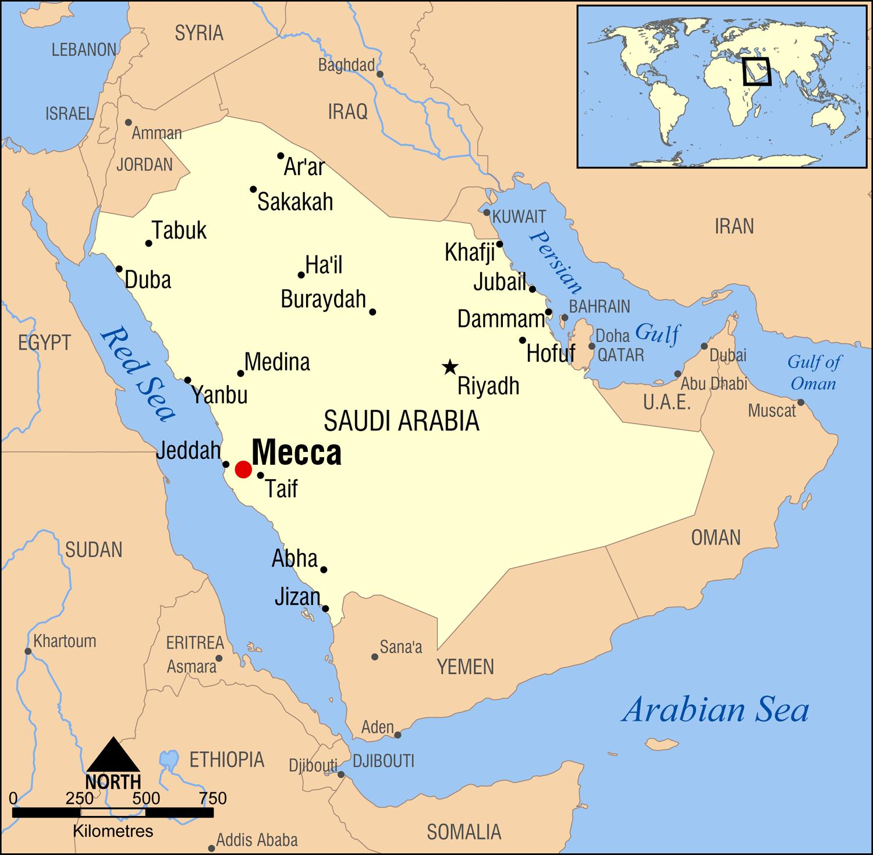

# **Legacy of Prophet Muhammad:**

## **6.1 Moral and Ethical Leadership:**

*The legacy of the Prophet Muhammad is characterized by his exemplary moral and ethical leadership, rooted in principles of honesty, integrity, compassion, and justice. His ethical conduct in personal and public life set a timeless example for leaders to uphold moral values, demonstrate integrity, and prioritize ethical decision-making in all aspects of leadership.*

## **Relevance to Leadership:**

*The Prophet's legacy of moral and ethical leadership underscores the importance of integrity, compassion, and justice in guiding leadership practices. Leaders can draw inspiration from Muhammad's ethical principles, commitment to honesty, and emphasis on fairness to cultivate a culture of trust, respect, and ethical conduct within organizations.*

## **6.2 Interfaith Relations and Religious Tolerance:**

*Throughout his life, the Prophet Muhammad promoted interfaith dialogue, religious tolerance, and peaceful coexistence among diverse communities. His interactions with people of different faiths exemplified respect, understanding, and cooperation, fostering harmonious relations and mutual respect among followers of various beliefs.*

***Relevant Quranic Verse: Surah Al-Kafirun (109:6)***

***“You have your religion and I have mine.”***

*emphasizes the acceptance of diverse beliefs and the importance of respecting different faith traditions, reflecting the Prophet's teachings on religious tolerance and interfaith harmony.*

## **Relevant Hadith:**

*In a Hadith narrated in Sunan Abi Dawood, the Prophet Muhammad emphasized the rights of non-Muslims living under Islamic rule, highlighting the importance of religious freedom, protection of minority rights, and respect for diverse religious practices.*

## **Legacy of Compassion and Mercy:**

*The Prophet Muhammad's legacy is also characterized by his compassion, mercy, and empathy towards all beings, including humans, animals, and the environment. His teachings on kindness, forgiveness, and empathy inspire leaders to cultivate a culture of compassion, care, and empathy in their interactions with others.*

## **Events Related to Legacy:**

* **Interfaith Dialogue:** *The Charter of Medina, a document that established the rights and responsibilities of diverse religious communities in Medina, exemplifies the Prophet's commitment to interfaith dialogue, religious pluralism, and peaceful coexistence. Leaders can learn from his efforts to promote religious tolerance, mutual respect, and cooperation among diverse communities.*
* **Humanitarian Initiatives:** *The Prophet's support for charitable activities, social welfare programs, and humanitarian aid reflects his legacy of compassion, generosity, and social responsibility. Leaders can draw insights from his emphasis on caring for the less fortunate, supporting vulnerable populations, and promoting social welfare as integral components of ethical leadership.*
* **Environmental Stewardship*:*** *The Prophet Muhammad's teachings on environmental conservation, sustainable living, and respect for nature highlight his legacy of environmental stewardship and ecological mindfulness. Leaders can emulate his teachings on environmental responsibility, resource conservation, and sustainable practices to promote a greener and more sustainable future.*

*By exploring the legacy of the Prophet Muhammad, including his moral and ethical leadership, interfaith relations, compassion and mercy, leaders can gain valuable insights into fostering ethical leadership practices, promoting religious tolerance, and cultivating a culture of compassion and care within organizations and communities.*

# **Prophet’s Year of Grief:**

## **7.1 The Boycott Imposed on the Prophet and His Followers:**

*In this chapter, we delve into the challenging period known as the Boycott, where the Prophet Muhammad and his followers faced a severe economic and social boycott imposed by the Quraysh tribe in Mecca. The Boycott aimed to isolate and weaken the Muslim community, depriving them of essential resources and support.*

## **7.2 Impact on the Muslim Community:**

*The Boycott inflicted immense hardship on the Prophet and his followers, leading to deprivation, hunger, and isolation. Despite the adversity, the Muslims remained steadfast in their faith and commitment to their beliefs, showcasing resilience and unity in the face of oppression.*

## **7.3 The Year of Grief:**

*The Year of Grief refers to a particularly challenging year in the life of the Prophet Muhammad, marked by the passing of his beloved wife Khadijah and his supportive uncle Abu Talib. These losses compounded the difficulties faced by the Prophet and the Muslim community, deepening their sense of grief and sorrow.*

## **7.4 Lessons in Resilience and Perseverance:**

*The experiences of the Boycott and the Year of Grief offer profound lessons in resilience, perseverance, and faith in the face of adversity. The Prophet's unwavering commitment to his mission, coupled with the support and solidarity of his companions, exemplifies the importance of steadfastness and unity in overcoming trials and tribulations.*

## **7.5 Relevance to Leadership:**

*Leaders can draw inspiration from the Prophet's response to the Boycott and the Year of Grief, learning valuable lessons in crisis management, resilience-building, and maintaining morale during challenging times. The example set by the Prophet underscores the significance of compassionate leadership, empathy, and strength in navigating periods of grief and hardship.*

*By exploring the Boycott and the Year of Grief in the life of the Prophet Muhammad, individuals can gain insights into the power of faith, unity, and perseverance in overcoming adversity and finding strength in times of sorrow and loss.*

# **Migration To Madinah:**

## **8.1 Journey to Taif:**

*In this chapter, we explore the Prophet Muhammad's journey to Taif, a city near Mecca, in search of support and acceptance for his message. Despite facing rejection and hostility from the leaders of Taif, the Prophet remained steadfast in his mission, demonstrating resilience and perseverance in the face of adversity.*

## **8.2 Lessons in Resilience and Patience:**

*The Prophet's experience in Taif teaches valuable lessons in resilience, patience, and trust in the divine plan. Despite the hardships and rejection he faced, the Prophet maintained his faith and commitment to spreading the message of Islam, showcasing unwavering determination and reliance on Allah's guidance.*

## **8.3 Migration to Madinah (Hijrah):**

*The migration to Madinah, known as the Hijrah, marks a pivotal moment in Islamic history when the Prophet Muhammad and his followers sought refuge and established a new community based on Islamic principles. The Hijrah symbolizes the triumph of faith over adversity and the establishment of a just and inclusive society.*

## **8.4 Relevance to Leadership and Strategic Planning:**

*The Prophet's strategic decision to migrate to Madinah highlights the importance of visionary leadership, strategic planning, and community-building in times of crisis. The Hijrah exemplifies the Prophet's ability to navigate challenges, forge alliances, and create a cohesive community dedicated to upholding justice and unity.*

## ***8.5 Leadership Lessons from Migration to Madinah:***

* **Vision and Strategic Planning:** *The Prophet's migration to Madinah exemplifies the importance of having a clear vision and strategic plan in times of adversity. By envisioning a new community based on Islamic principles, the Prophet laid the groundwork for a society built on justice, equality, and compassion.*
* **Community Building and Unity*:*** *The Hijrah underscores the significance of community building and fostering unity among diverse groups. The Prophet's efforts to unite the Ansar and Muhajir in Madinah demonstrate the power of collaboration and solidarity in overcoming challenges and building a strong, cohesive community.*
* **Resilience and Perseverance:** *The Prophet's migration to Madinah showcases the qualities of resilience and perseverance in the face of opposition and hardship. Despite facing threats and persecution in Mecca, the Prophet's determination to establish a safe haven in Madinah reflects his unwavering commitment to his mission and the well-being of his followers.*

*By examining the Prophet's journey to Taif and migration to Madinah, individuals can draw inspiration from his example of resilience, patience, and strategic leadership in navigating challenges and building a community based on faith, unity, and justice.*

# **Treaty of Hudaybiyyah**

## **9.1 Battle of Badr:**

*The Battle of Badr, a pivotal event in Islamic history, can indeed be analyzed through the lens of management principles. Here's a theory that explores the incidents and decisions made by the Prophet Muhammad (peace be upon him) during the Battle of Badr.*

* **Strategic Location:** *The Battle of Badr took place near a well called Badr, which was strategically located along the trade routes between Mecca and Medina. This location was crucial as it provided access to water and allowed control over the caravan rou"And [remember] when Allah promised you one of the two groups – that it would be yours – and you wished that the unarmed one would be yours. But Allah intended to establish the truth by His words and to eliminate the disbelievers"* ***(Quran, 8:7).***
* **Quraysh Caravan:***A wealthy Quraysh caravan, led by Abu Sufyan, was returning to Mecca from Syria, laden with valuable goods. Upon learning about the caravan's route, the Prophet Muhammad (peace be upon him) and his followers saw an opportunity to intercept it, hoping to compensate for their economic hardships in Medina.*
* **Decision to Confront Quraysh:** *Despite being vastly outnumbered and under-equipped, the Prophet Muhammad, upon consultation with his companions, decided to confront the Quraysh caravan. This decision was not solely driven by economic motives but also aimed at establishing the credibility of the Muslim community and ensuring their security.*

***"Those who have said about their brothers while sitting [at home], 'If they had obeyed us, they would not have been killed.' Say, 'Then prevent death from yourselves, if you should be truthful'" (Quran, 3:168).***

* **Strategic Maneuvers*:*** *Upon realizing the strength of the Quraysh army, the Prophet Muhammad strategically positioned his forces at a well-chosen location near Badr. He utilized the terrain to his advantage, stationing his troops in a defensible position with their backs against the hills.*

***"And [remember] when you left your family in the morning to post the believers at their stations for the battle [of Uhud] – and Allah is Hearing and Knowing" (Quran, 3:121)***

* **Leadership and Morale:***The Prophet Muhammad played a central role in leading and motivating his followers during the battle. His presence on the battlefield boosted the morale of the Muslims, inspiring them to fight with unwavering determination.*

***"So do not weaken and do not grieve, and you will be superior if you are [true] believers" (Quran, 3:139).***

* **Divine Intervention:** *According to Islamic tradition, divine intervention played a crucial role in the outcome of the battle. Angels were believed to have descended to aid the Muslim army, providing them with divine support and turning the tide of the battle in their favor.*

***"And when Satan made their deeds pleasing to them and said, 'No one can overcome you today from among the people, and indeed, I am your protector.' But when the two armies sighted each other, he turned on his heels and said, 'Indeed, I am disassociated from you. Indeed, I see what you do not see; indeed, I fear Allah . And Allah is severe in penalty'" (Quran, 8:48).***

* **Victory for the Muslims:***Despite being outnumbered, the Muslims emerged victorious in the Battle of Badr. They inflicted heavy losses upon the Quraysh army and captured a significant number of prisoners, including some notable leaders of the Quraysh.*

***"When you asked help of your Lord, and He answered you, 'Indeed, I will reinforce you with a thousand from the angels, following one another'" (Quran, 8:9).***

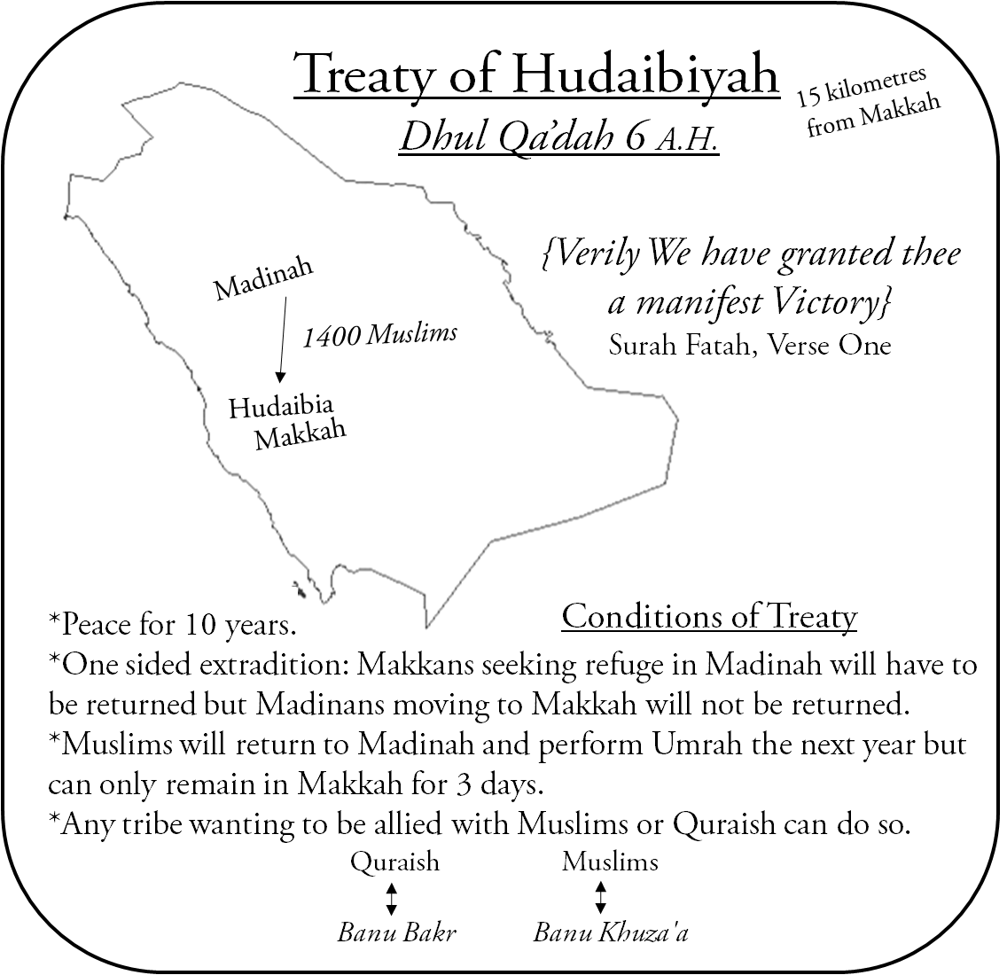

## 

## ***9.2 Leadership Roles:***

**Situation Analysis*:*** *The Prophet Muhammad (peace be upon him) and his followers faced a critical juncture. They were a relatively small and inexperienced force, facing a much larger and better-equipped enemy, the Quraysh of Mecca. The Quraysh had economic and military advantages, making the odds seemingly insurmountable.*

**Vision and Strategy:** *Despite the odds, the Prophet Muhammad had a clear vision: to stablish Islam and protect his followers. He devised a strategic plan based on limited resources and intelligence. He aimed not only for military victory but also for a psychological and strategic advantage.*

# **Leadership and Decision-making:**

* **Formation of a Unified Front:** *The Prophet Muhammad ensured unity and cohesion among his followers. He promoted a sense of brotherhood and commitment to the cause, aligning everyone towards a common goal.*
* **Strategic Decision to Engage:** *Despite being outnumbered and under-resourced, the Prophet Muhammad made the bold decision to confront the Quraysh. This decision wasn't impulsive but based on careful consideration of available intelligence, resources, and the morale of his followers.*
* **Utilization of Available Resources:** *The Prophet Muhammad utilized every available resource effectively. He strategized with his limited army, deploying them strategically to maximize their impact on the battlefield.*
* **Inspiration and Motivation:** *The Prophet Muhammad's leadership during the battle inspired and motivated his followers. His unwavering faith, courage, and determination instilled confidence in his companions, boosting their morale and resolve.*

### *9.3 Execution and Adaptation:*

* **Flexibility in Tactics:***During the battle, the Prophet Muhammad demonstrated adaptability in tactics. He adjusted his strategies based on the evolving battlefield conditions, exploiting weaknesses in the enemy's formation.*
* **Leading from the Front:** *The Prophet Muhammad led by example, actively participating in the battle. His presence on the frontline boosted the morale of his followers and symbolized his commitment to the cause.*
* **Effective Communication:** *The Prophet Muhammad maintained effective communication with his commanders and followers throughout the battle. Clear and concise instructions were given, ensuring coordinated action and response to changing situations.*

*The Battle of Badr resulted in a decisive victory for the Muslims, despite being outnumbered. This victory had profound implications, boosting the morale of the Muslim community and establishing the credibility of the Prophet Muhammad as a leader.Battle of Badr exemplifies strategic leadership principles applicable in modern management contexts. Through visionary leadership, effective decision-making, resource utilization, adaptability, and clear communication, the Prophet Muhammad achieved success against overwhelming odds. His leadership during this pivotal event provides timeless lessons for leaders facing challenges in various domains.*

# **After Hudaibiyah till blessed Aparent Demise:**

*Certainly! Here's a narrative covering the period from the Treaty of Hudaybiyyah until the blessed passing of the Prophet Muhammad (peace be upon him), interwoven with relevant.*

*After years of strife and struggle, the Treaty of Hudaybiyyah marked a pivotal moment in the history of Islam. Although it seemed like a setback at first, as it prevented the Muslims from performing Umrah, it ultimately paved the way for peace and prosperity. It was a testament to the Prophet Muhammad's (peace be upon him) unwavering commitment to achieving peace through diplomacy and negotiation, even in the face of adversity.*

***"Indeed, We have given you, [O Muhammad], a clear conquest." (Quran 48:1)***

### 10.1 trategic Planning :

*The Prophet Muhammad's (peace be upon him) strategic planning skills were evident in various battles and significant events during his lifetime.*

* **Battle of Hunain:** *The Prophet demonstrated his strategic acumen by gathering a large army to counter the threat posed by the tribe of Hawazan and other adversaries. Despite facing initial setbacks, he successfully reorganized his forces, turning the tide of battle.*
* **Battle of Tabuk:** *The Prophet's foresight and preparedness were on display as he organized an army to confront a potential Roman invasion despite severe weather conditions and resource constraints. This level of planning averted conflict, demonstrating the value of strategic preparation.*

### *10.2* Crisis Management and Flexibility:

*The Prophet's ability to manage chaos and adapt to changing circumstances reflects his crisis management skills and flexibility.*

* **Battle of Hunain:** *When an ambush disrupted the Muslim army's initial success, the Prophet's leadership helped stabilize the situation, ultimately leading to victory.*
* **Siege of Taif:** *After a prolonged siege with limited success, the Prophet decided to lift the siege, demonstrating flexibility and a focus on long-term goals.*
* **Leadership by Example:** The Qur'anic verse from Surah Al-Isra (17:1) points to the Prophet's night journey, emphasizing his spiritual journey and leadership by example:

**سُبْحٰنَ الَّذِیْۤ اَسْرٰى بِعَبْدِهٖ لَیْلًا مِّنَ الْمَسْجِدِ الْحَرَامِ اِلَى الْمَسْجِدِ الْاَقْصَا الَّذِیْ بٰرَكْنَا حَوْلَهٗ لِنُرِیَهٗ مِنْ اٰیٰتِنَاؕ-اِنَّهٗ هُوَ السَّمِیْعُ الْبَصِیْرُ(۱)**

"Glory be to Him who took His servant by night from the Sacred Mosque to the Farther Mosque, whose surroundings We have blessed, to show him some of Our signs."  
This verse represents the Prophet's ascension and his journey toward greater knowledge and understanding. In management, this journey reflects the need for leaders to continuously grow, learn, and lead by example, inspiring others to pursue personal and professional growth.

### 10.3 Inclusive Leadership:

*The Prophet Muhammad's inclusive leadership approach ensured that all individuals felt valued and respected, regardless of their background.*

* **Year of Delegations (9 Hijri):** *The Prophet welcomed various tribal leaders to Islam, engaging with them with a smile and patience, and ensuring they received proper guidance on Islamic principles. This approach contributed to the spread of Islam and the establishment of lasting relationships.*

### 10.4 Communication and Diplomacy:

*Effective communication and diplomacy were hallmarks of the Prophet's leadership.*

* **Sermons during Hajj:** *The Prophet demonstrated effective communication by appointing Hazrat Abu Bakr as Ameer Hajj and other companions to deliver sermons and convey new religious rules. His interactions with various delegations showed his ability to engage in meaningful dialogue, address tough questions, and provide guidance.*

### 10.5 Adaptability and Contextual Decision-Making:

*The Prophet's adaptability and contextual decision-making were evident in various events.*

* **Lifting the Siege of Taif:** *This decision reflected the Prophet's adaptability, as he adjusted strategies based on evolving circumstances.*
* **Diplomacy with Delegations:** *The Prophet's tailored approach to each delegation's unique background and concerns highlighted his ability to adapt and make contextual decisions.*

# **Blessed Attributes and Appearance of the Holy Prophet (PBUH)**

*The blessed attributes, habits, and virtues of the Prophet Muhammad (peace be upon him) offer additional insights into his leadership style and interpersonal skills, reinforcing key principles of effective management.*

## **11.1 Personal Presence and Charisma:**

*The Prophet's physical appearance exuded an aura of grace and dignity.*

* **Commanding Respect:** *His radiant face, calm demeanor, and composed posture contributed to his strong personal presence, helping him command respect and establish credibility.*
* **Interpersonal Skills and Approachability:** *The Prophet's softness and sweetness made him approachable and comforting to those around him.*
* **Empathy and Inclusion:** *His willingness to engage with everyone, from the weak to the mighty, underscored his empathetic and inclusive approach to leadership, fostering trust and open communication within a team or organization.*

**وَ لَوْ اَنَّهُمْ اِذْ ظَّلَمُوْۤا اَنْفُسَهُمْ جَآءُوْكَ فَاسْتَغْفَرُوا اللّٰهَ وَ اسْتَغْفَرَ لَهُمُ الرَّسُوْلُ لَوَجَدُوا اللّٰهَ تَوَّابًا رَّحِیْمًا(۶۴)**

"And if, when they wronged themselves, they had come to you and asked forgiveness from Allah, and the Messenger had asked forgiveness for them, they would have found Allah to be Most Accepting of Repentance, Most Merciful."  
This verse highlights the importance of recognizing one's mistakes and seeking forgiveness. In a management context, it underscores the need for leaders to encourage accountability and create an environment where team members feel safe to admit mistakes and seek reconciliation.

## **11.2 Clarity and Eloquence in Communication:**

*The Prophet's eloquence and clarity in speech enabled him to effectively communicate complex ideas and principles.*

* **Clear Communication:** *His ability to speak with fluency and clarity is a cornerstone of successful management, allowing leaders to articulate their vision and ensure understanding among their followers.*
* **Humility and Simplicity:**

*Despite his elevated status, the Prophet's life was marked by humility and simplicity.*

* **Modest Approach***: His preference for simple food, clothing, and transportation illustrates humility, fostering a culture of collaboration and minimizing hierarchies.*
* **Compassion and Empathy:**

*The Prophet's compassion extended to all, including his enemies.*

* **Kindness and Respect***: His emphasis on treating women with kindness and respect further exemplified his compassionate leadership, essential for building strong relationships and a supportive work environment.*

The Qur'anic verse from Surah As-Saba (34:28) emphasizes the Prophet's role as a communicator of good news and a warner:

* **وَ مَاۤ اَرْسَلْنٰكَ اِلَّا كَآفَّةً لِّلنَّاسِ بَشِیْرًا وَّ نَذِیْرًا وَّ لٰكِنَّ اَكْثَرَ النَّاسِ لَا یَعْلَمُوْنَ(۲۸)** "And We did not send you except to all of humankind as a bringer of good news and a warner."  
  This verse emphasizes the Prophet's role as a communicator, sharing important messages with clarity and conviction. In management, this aspect highlights the importance of clear communication and effective dissemination of information.

## **11.3 Integrity and Ethical Conduct:**

*The Prophet's honesty and integrity were universally recognized.*

* **Trust and Credibility***: His unwavering commitment to justice and fair treatment underscored the importance of ethical conduct in leadership, building trust and credibility.*
* **Adaptability and Versatility:**

*The Prophet's adaptability and versatility were evident in his clothing and transportation choices.*

* **Flexible Approach:** *His versatility demonstrated the importance of adaptability in management, allowing leaders to adjust to changing circumstances and embrace diversity.*

*The Qur'anic verse from Surah An-Nisa (4:64) emphasizes accountability and the importance of seeking forgiveness:*

**یٰۤاَیُّهَا النَّاسُ قَدْ جَآءَكُمُ الرَّسُوْلُ بِالْحَقِّ مِنْ رَّبِّكُمْ فَاٰمِنُوْا خَیْرًا لَّكُمْؕ-**

"O people! The Messenger has come to you with the truth from your Lord, so believe—it is better for you."  
This verse emphasizes the Prophet's universal message, transcending race, ethnicity, and culture. In a management context, it reinforces the importance of inclusivity and diversity in leadership, promoting a culture where everyone feels valued and included.

The Qur'anic verse from Surah Ad-Dhuha (93:1-5) reaffirms that the Prophet's legacy will endure:

**وَ الضُّحٰىۙ(۱) وَ الَّیْلِ اِذَا سَجٰىۙ(۲) مَا وَدَّعَكَ رَبُّكَ وَ مَا قَلٰىؕ(۳) وَ لَلْاٰخِرَةُ خَیْرٌ لَّكَ مِنَ الْاُوْلٰىؕ(۴) وَ لَسَوْفَ یُعْطِیْكَ رَبُّكَ فَتَرْضٰىؕ(۵)** "By the morning brightness and by the night when it is still, your Lord has not forsaken you, nor does He hate you. And the end will be better for you than the beginning, and your Lord will give you, and you will be satisfied."  
This verse reassures that the Prophet's legacy will grow and persist over time, pointing to a leadership style that creates lasting impact. In management, this reflects the need for leaders to build a legacy through positive actions, clear vision, and enduring impact.

# **Conclusion:**

* The journey through the life of the Holy Prophet Muhammad reveals timeless principles of management embedded within his narrative.
* From his early upbringing marked by resilience and empathy to his strategic planning and inclusive leadership, his life offers a blueprint for effective management in today's world.
* The Treaty of Hudaybiyyah stands as a testament to his diplomatic acumen and commitment to peace, showcasing the importance of strategic negotiation in resolving conflicts.
* His blessed attributes, including humility, clarity in communication, and ethical conduct, illuminate a path towards inclusive leadership and organizational success.
* As contemporary managers, we can draw inspiration from his life to navigate the complexities of leadership with integrity, empathy, and strategic foresight, ensuring sustainable success and positive impact in our organizations and communities.

## References:

* <https://www.dawateislami.net/bookslibrary/ur/aakhri-nabi-ki-piyari-seerat/ghazwah-or-sariya-ka-farq?pn=1&filterLang=ur>
* Quranic Verse (Surah Al-Ankabut 29:69):

This refers to a verse from the Quran, specifically Surah Al-Ankabut, verse 69. It emphasizes righteousness and guidance as essential for rectifying a morally declining society.

* Relevant Hadith (Tirmidhi):

This indicates a saying or tradition of Prophet Muhammad recorded in Tirmidhi, one of the six major Hadith collections in Sunni Islam.